s.no | 2 dimensional figures | Formula
1 | If s is the length of a side of a square then what is its Area.  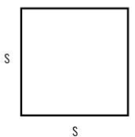
2 | If s is the length of a side of a square then what is its Perimeter.  
3 | If l is the length and w is the width of a rectangle then what is its Area.  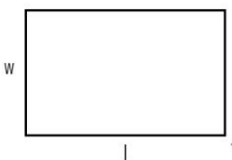
4 | If l is the length and w is the width of a rectangle then what is its Perimeter.  
5 | If a is the length of a side, b is the base and h is the height what is the Area of a parallelogram.  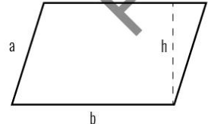
6 | If a is the length of a side, b is the base and h is the height which is the Perimeter of a parallelogram.  
s.no | 2 dimensional figures | Formula
7 | If a, c are the sides of a triangle, b is the base and h is the height, what is the Area of the triangle.  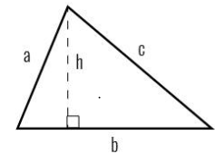
8 | If a, c are the sides of a triangle ,b is the base and h is the height, what is the Perimeter of the triangle.  
9 | If a, c are the lengths of the sides of a trapezoid, b1 and b2 are two parallel bases and h is the height then what is the Area of the trapezoid.  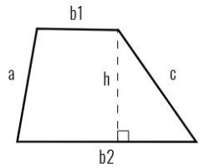
10 | If a, c are the lengths of the sides of a trapezoid, b1 and b2 are two parallel bases and h is the height then what is the Perimeter of the trapezoid.  
11 | If r is the radius and =3.14 what is the Area of a circle  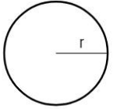
s.no | 2 dimensional figures | Formula
12 | If r is the radius and =3.14 what is the Circumference of a circle  
13 | If r is the radius, d is the diameter and =3.14 what is the Area of a semicircle (d=2r)  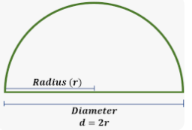
14 | If r is the radius, d is the diameter and =3.14 what is the Circumference of a semicircle (d=2r)  
15 | If r is the radius , d is the diameter and =3.14 what is the Area of a quarter circle (d=2r)  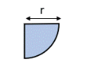
16 | If r is the radius , d is the diameter and =3.14 what is the Circumference of a quarter circle (d=2r)  

